Practical No. 6
Aim: Create a basic MANET implementation simulation for Packet animation and Packet Trace.

Steps:

- Open Omnet++ idle.

- Expand the inet folder > examples > manetrouting. Right click on manetrouting > New > Folder as MobileNet.
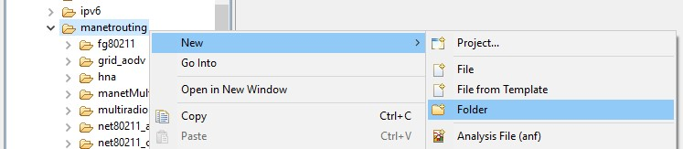
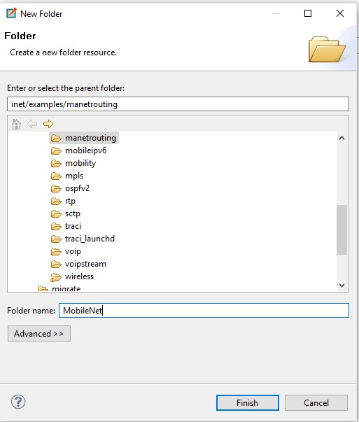
- Right Click on MobileNet > New > Network Description File (NED).
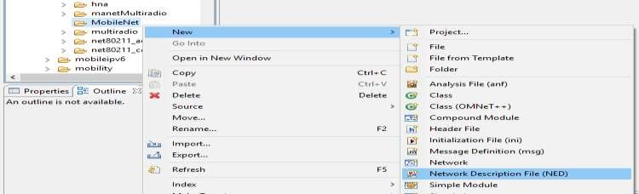
- Name the file as Net1 and Click Next.
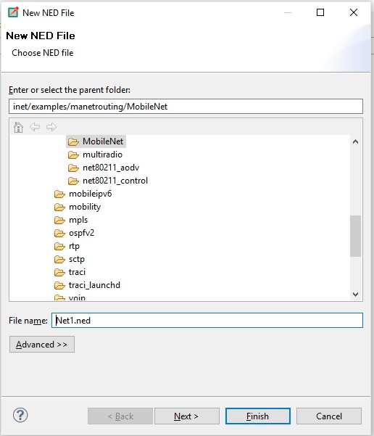

- Select New Adhoc Mobility Wireless Network Wizard and Click next.
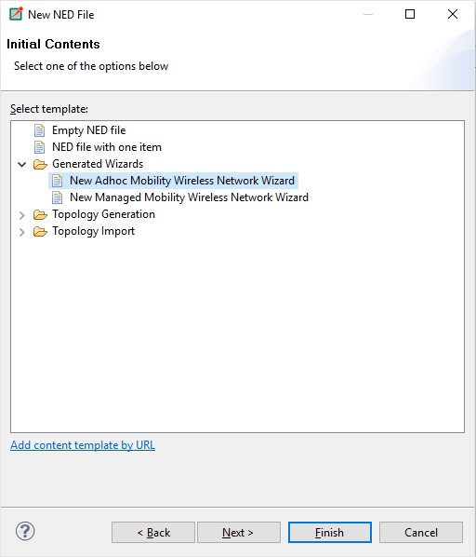
- Configure as follow.
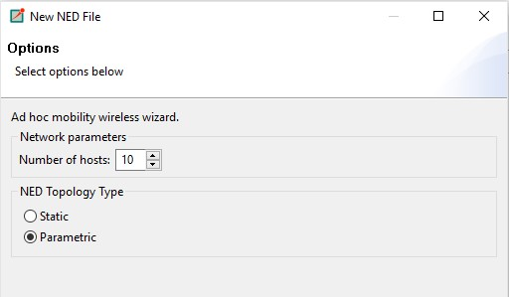

- Click on Finish.
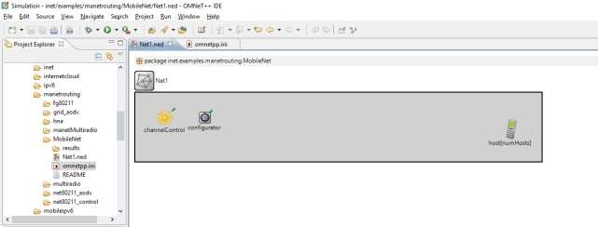
- To configure, Right click on inet folder > Run as > Run Configurations. Select Net1 > Browse the directory where the project is > Apply > Run.
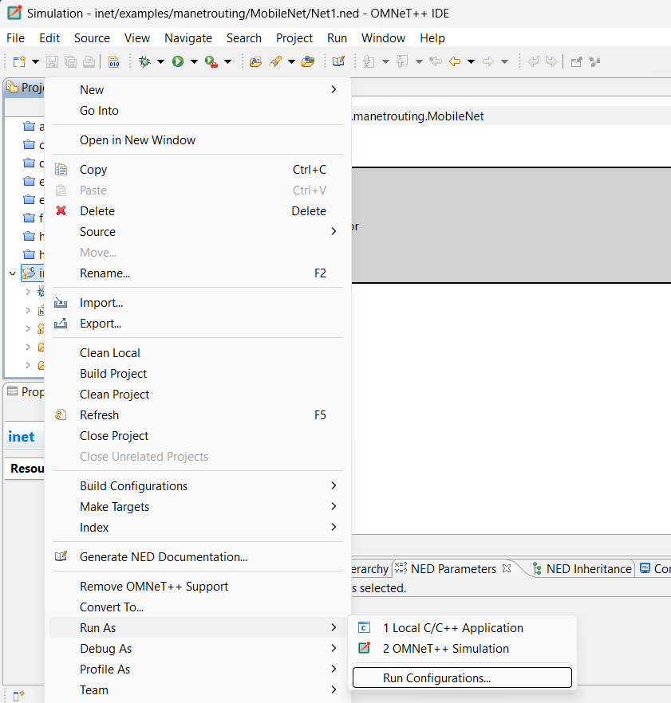
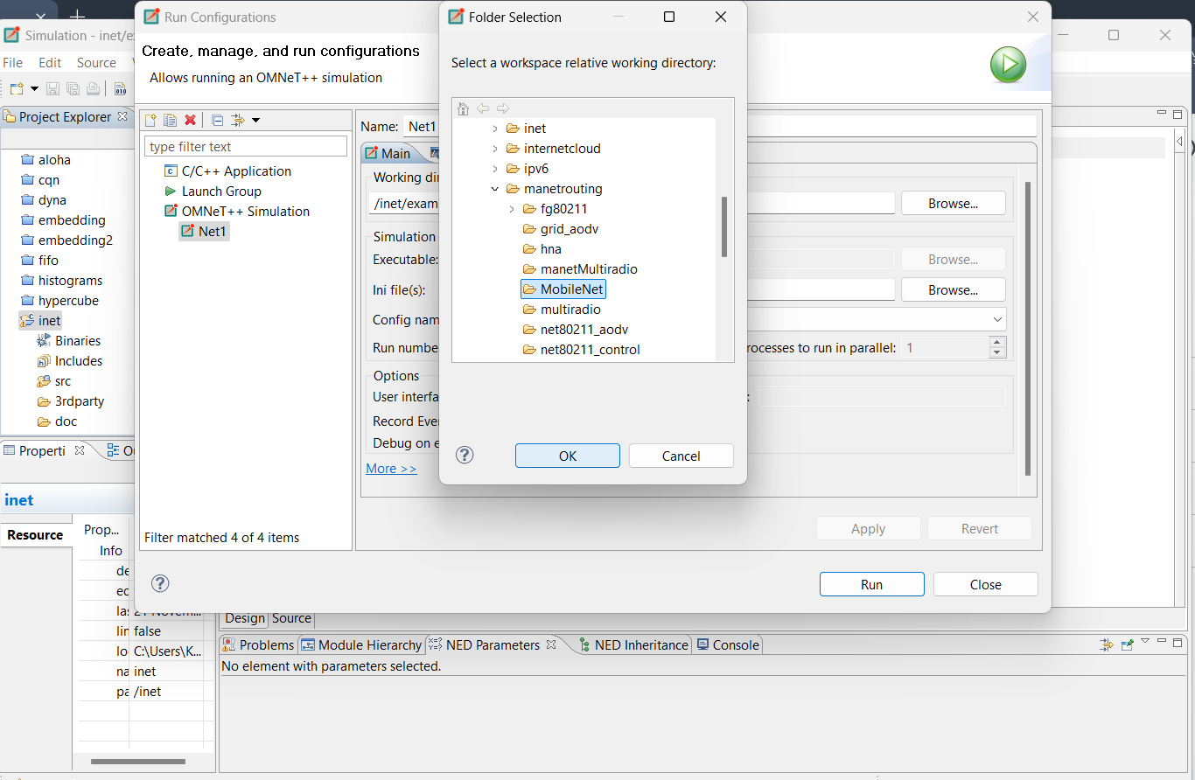

Output:

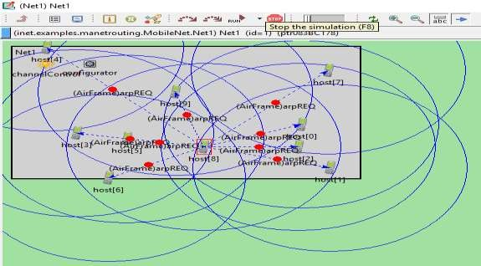

Below is the code that will be available in source part of net1.ned once configured.
package inet.examples.manetrouting.MobileNet;

// numOfHosts: 10
// parametric: true
// static: false

import inet.networklayer.autorouting.ipv4.IPv4NetworkConfigurator; import inet.nodes.inet.AdhocHost; import inet.world.radio.ChannelControl;

network Net1
{ parameters:
int numHosts; submodules:
host[numHosts]: AdhocHost
{ parameters:
@display("r=,,#707070");
}

channelControl: ChannelControl
{ parameters: @display("p=60,50");
}

configurator: IPv4NetworkConfigurator
{
@display("p=140,50");
}
}

A file omnetpp.ini will be created with the following source code.
[General] network = Net1 #record-eventlog = true
#eventlog-message-detail-pattern = *:(not declaredOn(cMessage) and not declaredOn(cNamedObject) and not declaredOn(cObject))

*.numHosts = 10

num-rngs = 3 **.mobility.rng-0 = 1
**.wlan[*].mac.rng-0 = 2
#debug-on-errors = true

tkenv-plugin-path = ../../../etc/plugins

**.channelNumber = 0

# channel physical parameters
*.channelControl.carrierFrequency = 2.4GHz
*.channelControl.pMax = 2.0mW
*.channelControl.sat = -110dBm
*.channelControl.alpha = 2
*.channelControl.numChannels = 1

# mobility
**.host[*].mobilityType = "MassMobility"
**.mobility.constraintAreaMinZ = 0m
**.mobility.constraintAreaMaxZ = 0m
**.mobility.constraintAreaMinX = 0m
**.mobility.constraintAreaMinY = 0m
**.mobility.constraintAreaMaxX = 600m
**.mobility.constraintAreaMaxY = 400m
**.mobility.changeInterval = truncnormal(2s, 0.5s)
**.mobility.changeAngleBy = normal(0deg, 30deg)
**.mobility.speed = truncnormal(20mps, 8mps)
**.mobility.updateInterval = 100ms

# ping app (host[0] pinged by others)
*.host[0].pingApp[0].destAddr = ""
*.host[*].numPingApps = 1
*.host[*].pingApp[0].destAddr = "host[0]"
*.host[*].pingApp[0].startTime = uniform(1s,5s)
*.host[*].pingApp[0].printPing = true

# nic settings
**.wlan[*].bitrate = 2Mbps

**.wlan[*].mgmt.frameCapacity = 10
**.wlan[*].mac.address = "auto"
**.wlan[*].mac.maxQueueSize = 14
**.wlan[*].mac.rtsThresholdBytes = 3000B
**.wlan[*].mac.retryLimit = 7
**.wlan[*].mac.cwMinData = 7
**.wlan[*].mac.cwMinMulticast = 31

**.wlan[*].radio.transmitterPower = 2mW
**.wlan[*].radio.thermalNoise = -110dBm
**.wlan[*].radio.sensitivity = -85dBm
**.wlan[*].radio.pathLossAlpha = 2
**.wlan[*].radio.snirThreshold = 4dB

